Opened Meeting at 6:30 am with Serenity Prayer
March 25, 2017 Tampa, FL

Reading of Mission Statement

Roll Call

Participants Introduction
1. Alabama-NW/FL Region
Harold H. RD
Kelly S – AD - Absent
2. Carolina Region
John F. RD
Stephanie AD
3. Georgia Region
Greg S. RD
Jeremy L. AD – Absent
4. Florida Region
Bob L. RD
Biff K AD
5. North Carolina Region
Neil S. RD
Danny G AD
6. South Florida Region
Jeff P. RD
Kevin D. AD
Kevin D. - Web Servant
Mike G. - Facilitator
Carlos N. – Secretary/ Treasurer
All Regions were present or represented

Introduction of Members at Large

Ground Rules / Setup were read

Approval of Minutes (from July 31, 2016): Consensus reached on approving minutes

NA Service Statement was read

Regional Reports

Alabama/ NW Florida:

ALNWFL Regional Report 03/25/17

Hello Everyone from the Alabama Northwest Florida Region Delegate Team;

The ALNWFL continues to make strides in area of providing services to the addict that still suffers.
We are continuing to utilize the adobe connect to conduct regional business with an intent of reducing discussion at the RSC by having issues brought to the adobe connect meeting for discussion and possible resolution. We have had some internal and external issues but has still found this to be a valuable tool for our region. We have a proposal that has gone back to areas for ALNWFL to purchase our own license.
Our list of upcoming events are as follows; The Greater Mobile Area is having their convention this weekend.

We are excited about our upcoming regional convention, Fun In The Sun, which will take place , April 27-30 in Panama City Beach Florida. Last year, we registered over three hundred newcomers. We require the newcomer to attend a newcomer workshop where we explain to them the importance of “Why Register”, and then we give them a free registration. This activity has shown great promise. we've actually had some of those newcomers return the next year, register, and then either register a newcomer or give a newcomer donation. It's all in the spirit of “You keep what you have, by giving it away.

One Issue that we are dealing with is, in one of our areas, the court system is asking that the chair person of the meeting that signs the meeting slip, give an assessment on the participating member. We are not complying with them, and the RCM of that area has set a meeting the the court system which includes the sheriff and the Judge. We had to wait until after the local election to schedule the meeting. The old administration is out and we will meet with the new administration to let them know our position.

Looking forward, our plans as a delegate team is to utilize every opportunity we can to strengthen up our RCM's, who can be a tool used to strengthen up our GSR's of our region. We are extremely concern with H&I activity in our region. We really need to understand that these committee members are carrying a clear message of narcotics anonymous into the various facilities that we service. The greater Birmingham area has a strong H&I subcommittee that we believe we can benchmark.

That is all for now

Thanks for allowing me to be of service,
Harold H
Regional Delegate
Alabama Northwest Florida Region of NA

HOLIDAY INN EXPRESS & SUITES
BIRMINGHAM NE-TRUSSVILLE
5911 Valley Road, Trussville, AL 35173 T: (205) 655-2700 F: (205) 655-5500
Hiexpress.com/trussvilleal Sales Dept. Email: hitrussville59@yahoo.com
`

Group Name: NA of the Southeast Arrival Date: 02/28/2017 Booked: 02/16/2017
Group Contact: Harold Holleman Phone: 205-243-7854
Email:Operator19140@bellsouth.net
Group Code/Type: NAS

GROUP ROOM AND/OR MEETING ROOM ARRANGEMENTS
ROOM TYPE | RATE | 07/28/17 | 07/29/17 | 07/30/17
Standard King | $89.99 | 10 | 10 | Checkout
Standard Queen/Queen | $99.99 | 5 | 5 | Checkout
Meeting Room* |  |  | $125.00 + $50.00  Cleaning Fee  8am-5pm | $125.00 + $50.00  Cleaning Fee  8am-12pm
TOTAL ROOMS/NIGHTS |  | 15 | 15 | Checkout
All room rates are subject to state & local sales tax & occupancy taxes (total taxes: 14%)
RESERVATIONS: For call-in reservations, guests may call toll free at 855-715-3671 & reference the group name above or they may reserve online, via the FREE customized booking link (issued once the signed agreement is received).

RESERVATIONS CUT-OFF DATE: 07/14/2017 (All unreserved rooms to be released back into hotel’s sell inventory on this date). Rooming list(s) due on this date, if applicable.

GUARANTEE & BILLING:
Guarantee Method: A credit card is required, at time of reservation.
Payment/Billing: Guests are responsible for all charges.

CANCELLATION POLICY: Cancel individual rooms by 3pm, on the day PRIOR to arrival. IF CANCELLATION OF THE ENTIRE GROUP BOOKING BECOMES NECESSARY, TO AVOID FORFEITURE OF ANY DEPOSITS PAID OR PAYMENT OF PENALTIES, THE HOTEL MUST RECEIVE WRITTEN NOTIFICATION NO LATER THAN 2 WEEKS PRIOR TO ARRIVAL DATE. An Act of God, which prevents specified cancellation, policies & terms of this agreement (except where exception is specified.

Carolina:
NO REPORT

Florida:
To SEZF
From Bob and Biff
RD/AD, Florida Region
March 25, 2017
Re: Report to SEZF
Hello from the Florida Region. Since our last get together in December, we have had one RSC and a lot of Conference Calls concerning this weekend and the Florida Service Symposium. The energy and efforts of all concerned have brought good vibes to the entire body. And in past Symposiums, it is always a good thing to have new blood, new ideas and new perspectives.
In light of the FSS, Biff and I have made a commitment to contact the RCM’s personally; offering our service in person at their ASC’s, inviting them to attend the RSC weekends especially on Saturdays where we will be discussing IDT’s this Conference Cycle and to encourage greater participation, etc. Our invitation will include the suggestion to bring others within their Area to experience the RSC weekend activities especially this exciting weekend. A benefit to addicts in the Florida Region for the FSS is that we pay for four room-nights per Area in order for members to experience the Service Symposium.
We are grateful that World Services saw that the FSS was an excellent opportunity to talk about the issues that are in front of us. Expected presentations on The Future of the WSC, World Convention 2018 and of course an excellent NAWS Update will be certain to be of great interest to all. We thank Danny G for taking on the lead role of putting together the IT Track – thank you Danny and his team of techies. We will have our History buffs in attendance which is always interesting and an invitation was accepted by Sandy from the ABCD Region to present a PowerPoint on an Idea for Zones (following our breakfast).
We are happy that you have chosen to attend and hope that this weekend was enjoyable and interesting. Thank you to those who participated by speaking and for the workshops you may take part in.
Now that WCNA discussions have begun to take shape, we are assisting convention planners with seeking volunteers. Right now we ask that if you wish to volunteer, you can visit www.floridana.org and fill out a request to be of service. As we receive further information, we will post the information on the Florida website as well as the SEZF website. We hope you will all promote the soon to be largest and best World Convention in NA history
Finally, thank you for being with us here in THE Florida Region!
Georgia:
Georgia Zonal Report
March 2017

Regional Activity

The Georgia Region has some bright spots along with some areas of weakness. The efforts of PR and H and I have been consistent and value added in carrying the message. Additionally we are writing the Georgia History Book which is coming along well. The weakness we have is that our budget has grown as our donation have fallen therefore driving us below prudent reserve. Another issue we have been working through is some dissention within one of our areas.

PR and H and I

These two committees have been working diligently over the last several years (or as long as I have been affiliated with the region). The committees have had good leadership and sustained momentum. These committees are well attended at every RSC. PR has particularly benefited from the Zonal IT expertise of the “Think Tank”. Additionally we have launched a new Web Site which is much improved from our old model. H and I was the beneficiary of Basic Texts from the East Coast Convention. The committee chair expressed gratitude.

Georgia History Book

The Georgia History Book project is well into its second year however that may be a little misleading. The project has a vast archive of literature and interviews it its disposal due to the efforts of a few members of the region. The Georgia history Display has been in place for 15 years and was interviewing members and accumulating these archives. When the History Book Project kicked they had a head start. As of today there are over 50 recorded interviews with members with greater than 30 years clean. The committee has been seeking guidance from many sources however New York, which has recently published, has been particularly helpful.

Area Issues

One particular area has recently split. One issue that was at the root cause was the incorporation of the ASC. After the incorporation was completed the ASC decided they want to dissolve the incorporation, but that was denied by the Board of Directors. The area by a majority vote changed their name and moved the bank account. Much of the motive of the incorporation was driven by a new convention. At this point the individuals have seemed to arrive at middle ground. Therefore we have added a new ASC.

Budget

The main topic at the last RSC was the budget. We have fallen below prudent reserve for the last six months. Recently we have elected a new treasurer who has some excellent financial skills. We are under way with a full effort to diagnose the income as well as expense profile of the region. A full report will be rendered at the June RSC. There is a concern that going into the next 12 months we will have the additional burden from the Conference expenses. Three years ago we voted to pay for the RD and AD for the conference.

In Closing

Georgia is committed to the Zone however at this time we are unable to support the zonal budget until we get our affairs in order.

Take Care

Greg

North Carolina:
North Carolina Region

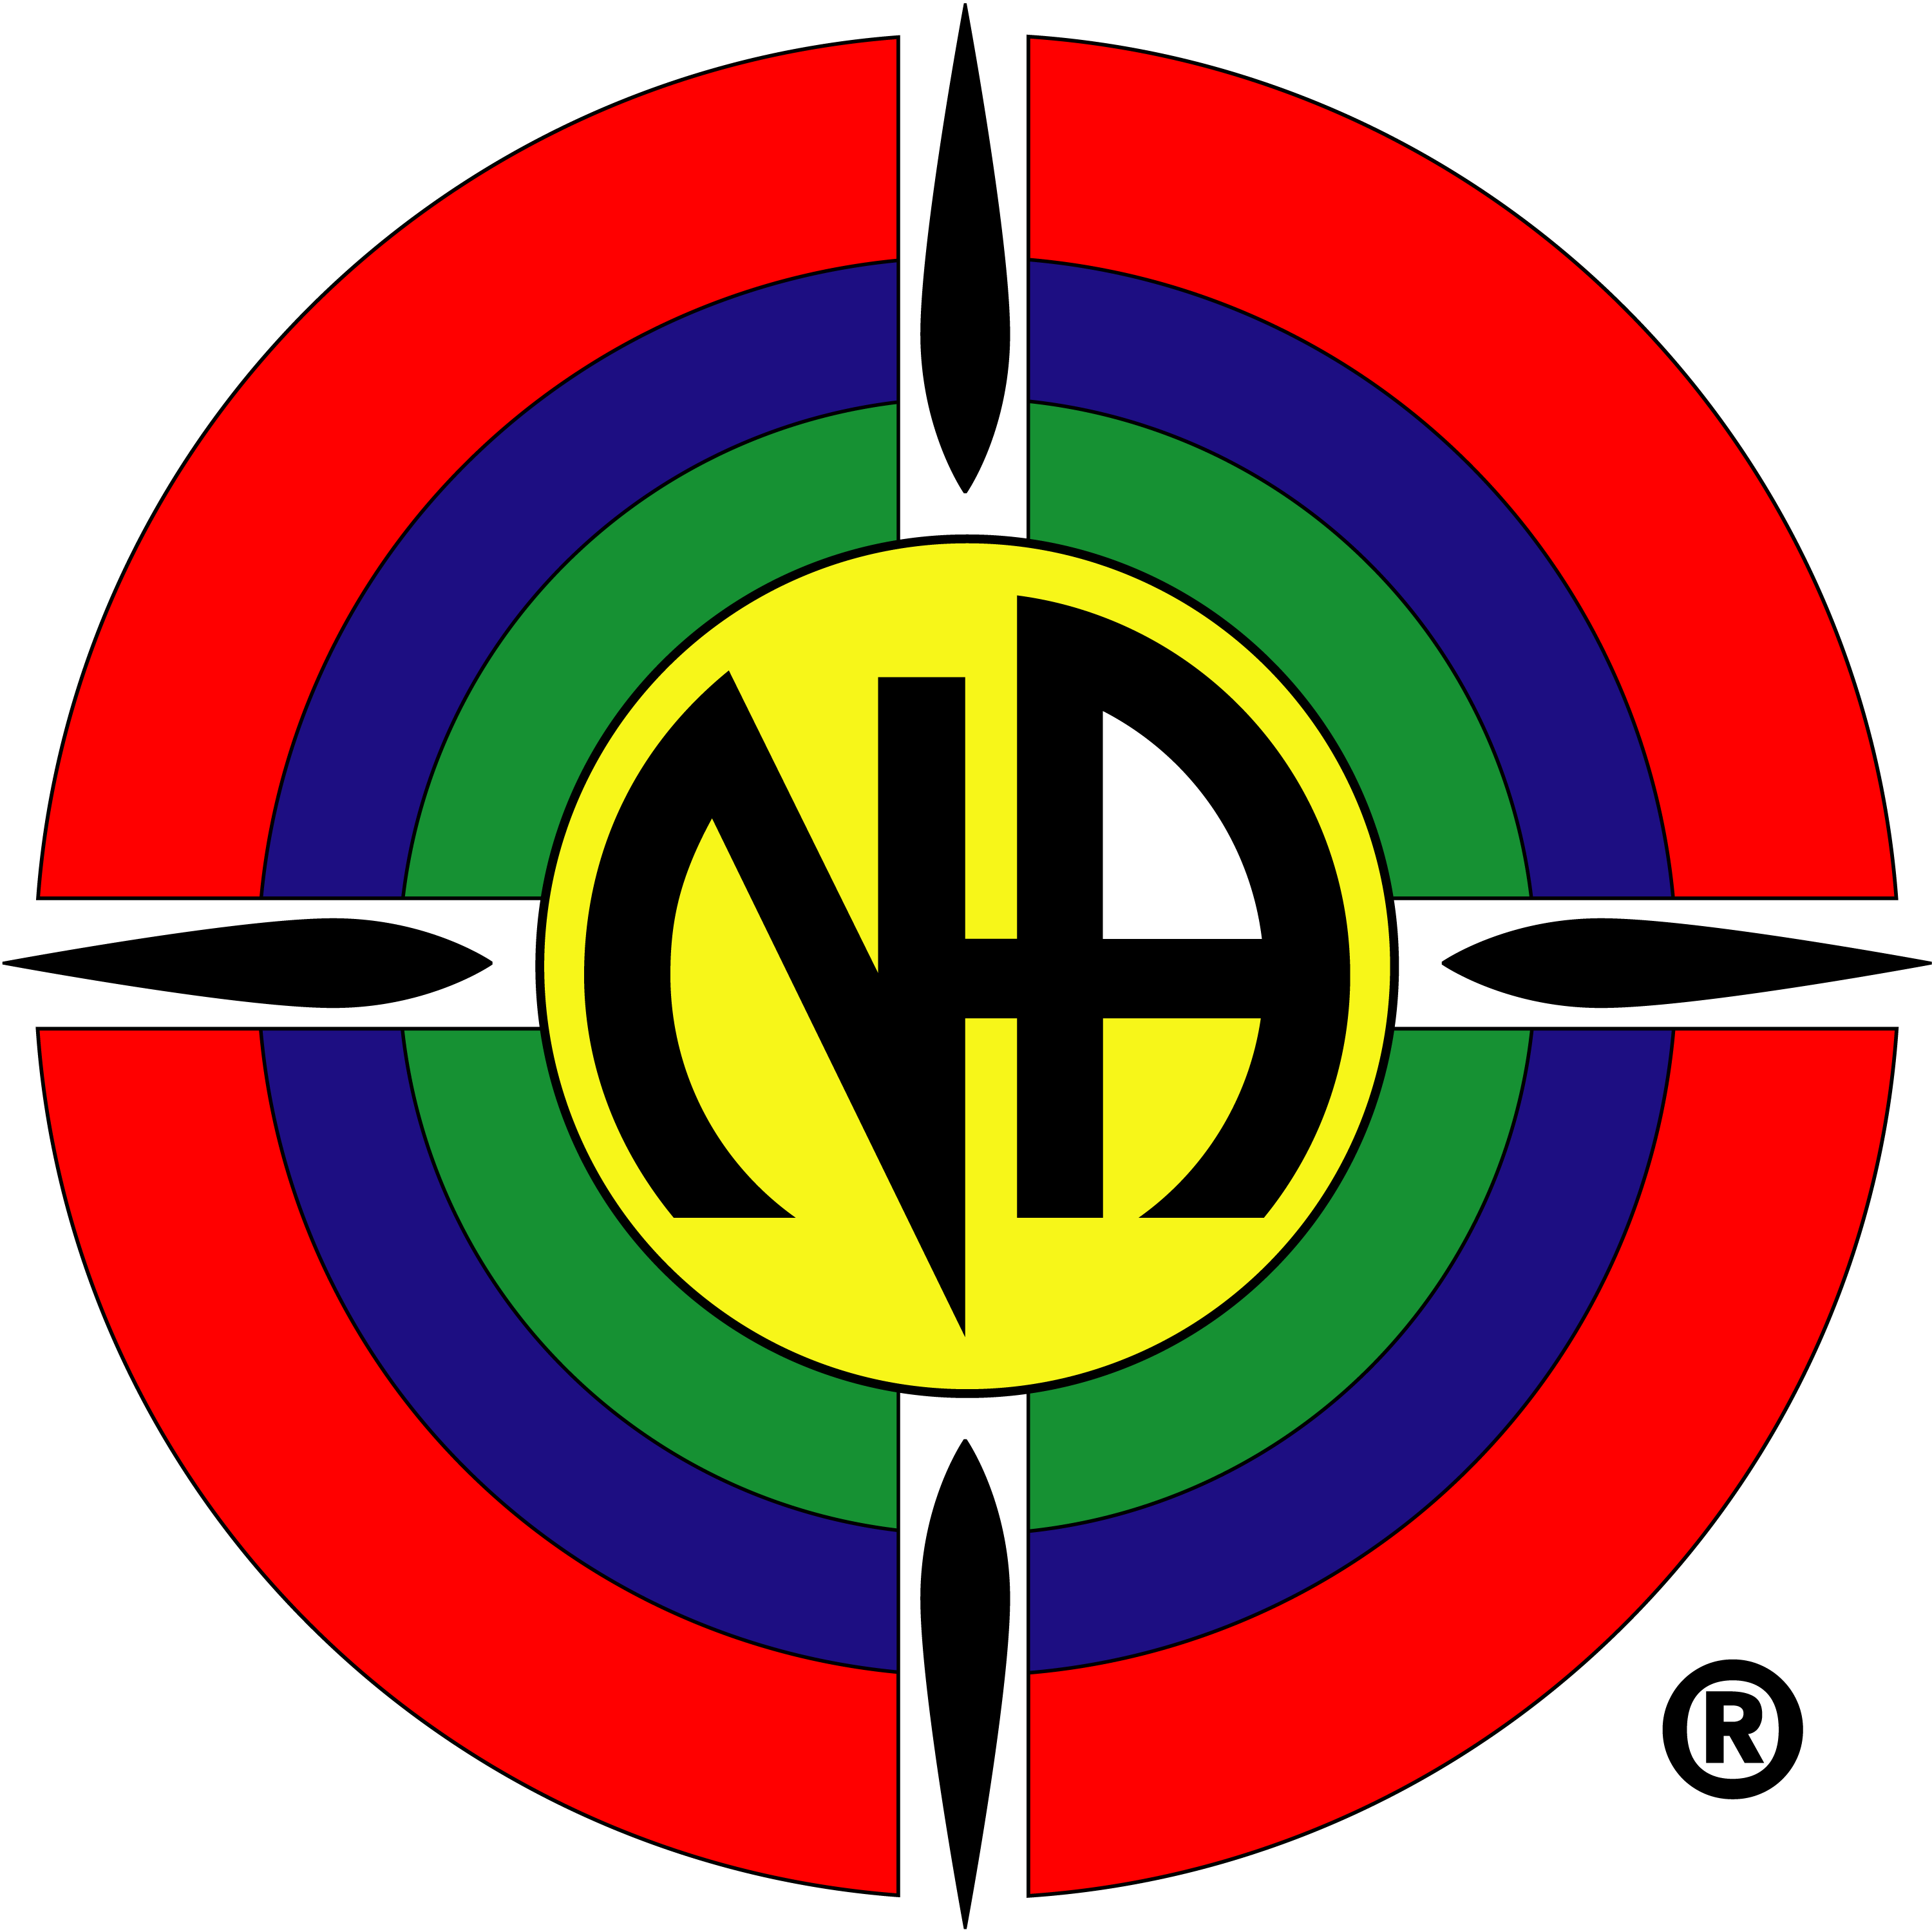
Of Narcotics Anonymous

RD Report to the SEZF

March 2017 – Tampa Florida

The North Carolina Region is doing well.

Thank you guys for coming to Greensboro and sharing your experience strength and hope in the workshops with our local community.

We have had one RSC since we met last.

Based on previous conversations that we have had in the region and the limited conversations that we have had about zonal seating at the SEZF, we just passed proposal BD on the our member areas to see if there is desire to workshop or discuss further.

We inserted the SEZF into our fund flow. 75% to NAWS 25% to the SEZF about our prudent reserve of $5000. Checks will be automatically written and sent to the SEZF treasurer.

We are working on the environmental scan for NAWS and will submit next month.

Our 1st GSR assembly is next month April 29th from 11-4. We will be doing the exact workshop on the guiding principles that was learned here as well as a workshop on the future of the WSC based on what we learn today and at least one other workshop that we learned here as well. We will also conduct information sessions for GSRs concerning our service structure.

In Service,

RD/AD team, North Carolina Region of Narcotics Anonymous
neal@nsengineering.com
(910) 690-9862

South Florida:
South Florida Region Report

Everything in the South Florida Region is running smoothly. All our positions are filled and service rocks!!

We have a bunch of members interested in the Zonal PR task force and one for the H&I task force.

We’ve submitted some regional recommendations to HRP for WSC positions, Bobby S for World Board and Wally I for WSC Co-Facilitator

We’re in the process of compiling information for the NAWS environmental scan. It’s been a bit like pulling teeth, so far.

Our region passed a motion to perform an inspection of the records of NAWS as per the FIPT. I’m expecting to submit the request by the end of April and have the inspection some time during the summer.

Thanks to the Florida Region for an excellent Symposium. We have more members here from South Florida then we’ve had in a very long time

In Loving Service,

Jeff P – RD
Kevin D - AD

Web servant Report:
Minutes have been added.
Some resources have been added.
Danny given temporary access to install his BMLT aggregator.
Looking to add FSS powerpoints when submitted.
Looking for more events to add to calendar - please submit flyers digitally to darkstar33444@yahoo.com
)

Secretary/ Treasurer Report:
SEZF Secretary/ Treasurer Report for December Zonal Forum
To the Regional Delegates:
The SEZF bank account has a current balance of $4794.01. No deposits since 12/04/2016. Expenses since 12/04/2016 totaled $796.41

Old Business:
- Lists for H&I and PR taskforces turned in to Jeff Paul.
- Descriptions for PR and H&I Taskforces agreed upon via consensus.
- Kevin D. will coordinate initial meetings of taskforces.

Elections:
NO ELECTIONS

New Business:
- ECC requests to use SEZF Adobe Connect – consensus (Danny recommends we begin to explore ZOOM technology used by World Services – refer discussion to July SEZF)
- Craig R – seeking nomination of SEZF for WHRP – tabled to regions
- Future of Zones workshop facilitated by Frannie of WB convened during forum.

Event Calendar: SEZF is scheduled to meet July 28 – 30 in Birmingham, AL. See addendum to ANWFL report for hotel information.

Zonal Meeting Schedule: July 28-30 Birmingham, AL hosted by Alabama Northwest Florida Region

Discussion –
- Georgia Region reports movement to Consensus Based Decision Making
- Invites all to see new website at grscna.org
- Georgia region experiencing budgetary issues
- S FL and Carolina has increased prudent reserves
- FL Region experiencing issues with hotel costs for RSCs
- FL Region seeking volunteers for WCNA 37 and will discuss linking/ collaboration with S FL Region
- N Carolina reports 25% of monies above prudent reserve will go to SEZF
- Agenda for July SEZF: Outreach, World Board, RCM workshop on effective leadership, the group workshop, and delegate workshop suggested topics
- Agenda to be published in advance of forum.

